**Objective:** To configure Windows Firewall to block inbound traffic on Port 23 (Telnet) and allow inbound traffic on Port 22 (SSH), and verify the configuration through testing.

### **1. Initial Firewall Status**

* Opened *Windows Defender Firewall with Advanced Security* to review existing inbound and outbound rules.  
  **:**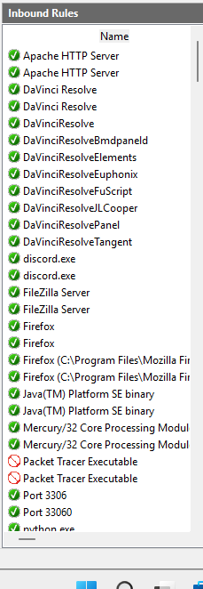

### 

### 

### 

### 

### **2. Block Inbound Traffic on Port 23 (Telnet)**

**Steps performed:**

1. Opened *Windows Defender Firewall with Advanced Security*.
2. Selected **Inbound Rules → New Rule**.
3. Chose **Port → TCP → Specific Local Port: 23**.
4. Selected **Block the connection**.
5. Applied to all profiles (Domain, Private, Public).
6. Named the rule Block TCP Port 23.
7. 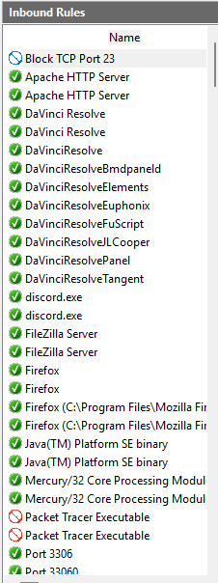

### **3. Test – Verify Port 23 Block**

* Method: Ran Nmap and/or Telnet test to check Port 23.

Command used (PowerShell or CMD):  
  
 Copy code  
Test-NetConnection -ComputerName 127.0.0.1 -Port 23

or  
  
 nginx  
Copy code  
nmap -p 23 127.0.0.1

* **Expected result:** Port 23 connection fails / state is “filtered”.



### **4. Allow Inbound Traffic on Port 22 (SSH)**

**Steps performed:**

1. Opened *Windows Defender Firewall with Advanced Security*.
2. Selected **Inbound Rules → New Rule**.
3. Chose **Port → TCP → Specific Local Port: 22**.
4. Selected **Allow the connection**.
5. Applied to all profiles.
6. Named the rule Allow TCP Port 22 (SSH).

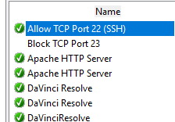

### **5. Test – Verify Port 22 Allow Rule**

* Without SSH server: Nmap shows **closed** (no service listening) but not **filtered**, meaning firewall is allowing traffic.
* With SSH server installed (OpenSSH Server on Windows): Nmap shows **open**.

Command used:  
  
 nginx  
Copy code  
nmap -p 22 127.0.0.1

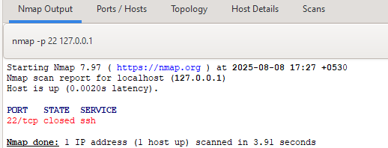

### **6. Conclusion**

The firewall was successfully configured to:

* Block inbound traffic on Port 23 (Telnet).
* Allow inbound traffic on Port 22 (SSH).  
   Testing confirmed that the firewall rules were applied correctly.  
   This demonstrates the ability to configure network filtering rules and verify them using command-line tools.

### **7. References**

* Microsoft Documentation: *Configure Windows Defender Firewall Rules*
* Nmap.org: *Port Scanning Basics*